ZHENG ZHOU YIFAN MACHINERY CO; LTD.
Tel：0086-371-64628852 Fax：0086-371-64628872
Address：Xingyang Eastern Development Zone, Zhengzhou, PRC.

Stone production line
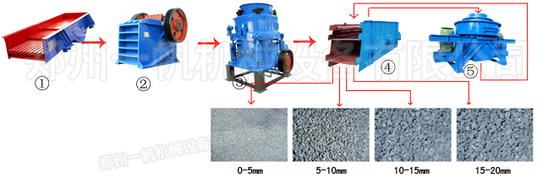
Stone production line is composed by feeder, jaw crusher, impact crusher or cone crusher, vibrating screen and vertical shaft impact crusher ect. Supported by the belt conveyor, it is a whole processing chat for stone producing.This plant have high efficiency and processing capacity with low cost.
Process flow of stone production line:
Material is fed by feeders into jaw crusher for primary crushing. Then material with suitable partical size will come out from jaw crusher and goes into Impact or cone crusher for secondary crushing. And then finished materials goes to vibrating screen for gradation. Satisfactory material is transported by conveyor belt. Output sizes is determined by model of crusher and vibrating screen.
SMH series hydraulic cone crusher adopting world advanced technology is designed and made through to be the crusher of world advanced level. it is widely used in metallurgical, architectural, water and electricity, traffic, chemical, architectural material industries. It is suitable for crushing varies of mid hard and above mid hard ores and rocks. YIFAN cone crusher has higher performance. The rotate speed, stroke and crushing chamber of the cone crusher had been redesigned and regrouped by our researcher so that Intergranular laminating crushing had been realized.

For further details, please visit our website: www.yfcrusher.com .
International trade department
Tel: +86-371-64628852, +86-371-64963352
Fax:+86-371-64628872
Email: yifan@yfcrusher.com
MSN Online: wyh787415@yahoo.com.cn

